GOING HOME SAFELY
Before you leave hospital: equipment and telecare to help you get home safely
Going home after a hospital stay is an important step. For many people, returning to their own home helps them regain confidence, independence and routine. However, it is also important to make sure the home environment is safe and that the right supports are in place from the beginning.
The role of the Occupational Therapist (OT)
An Occupational Therapist looks at how a person manages everyday activities such as getting in and out of bed, using the toilet, washing, dressing, preparing meals and moving around the home. Sometimes a small change – the right chair height, a grab rail, or a personal alarm – can make a big difference. The aim of equipment is not to take away independence: it is to help a person do things more safely and with greater confidence.

EQUIPMENT TO CONSIDER BEFORE GOING HOME
The equipment needed will depend on the person's individual abilities, their home layout and the activities they find difficult. The most important question when thinking about equipment is:
“What tasks could become unsafe at home, and what support would help the person complete them safely?”

Below are some common areas where equipment may be considered, with why each option might help.

1. Toileting Equipment
Getting to and using the toilet is one of the most important things to consider before discharge. People often feel worried about managing the toilet independently, particularly after illness, surgery, weakness or a fall.
Raised Toilet Seat
A raised toilet seat increases the height of the toilet, making it easier to sit down and stand up.
Why this may help:
- Reduces the distance a person needs to lower themselves
- Makes getting on and off the toilet easier for someone who is weak or has reduced balance
- Can reduce the risk of losing balance when standing

Toilet Frame or Toilet Rails
These provide support when lowering onto and rising from the toilet.
Why this may help:
- Gives the person something stable to hold
- Reduces reliance on furniture or unsafe surfaces for support
- Can increase confidence when using the toilet alone
Commode
A commode is a portable toilet that can be placed near the bed or in another suitable area.
Why this may help:
- May be considered if walking to the bathroom is unsafe
- Can reduce falls risk, particularly overnight
- May be useful during early recovery when strength and mobility are still improving

2. Bathroom Safety Equipment
Bathrooms can be one of the highest-risk areas in the home because of slippery surfaces, transfers and reduced balance.
Shower Chair or Shower Stool
Why this may help:
- Allows the person to sit while showering
- Reduces fatigue and the risk of losing balance when standing
- Can make personal care safer and less tiring
Bath Board or Bath Transfer Equipment
Why this may help:
- Supports people who find stepping into or out of the bath difficult
- Reduces the risk of slipping during transfers
However, not everyone is suitable for bath equipment. Sometimes the safest option is to change how bathing is completed rather than adding equipment.
Grab Rails
Rails may be considered near:
- The toilet
- Shower area
- Bath
- Steps or stairs
- Entry and exit points
Why this may help:
- Provides a secure point of support
- Helps with balance during specific movements
- Can reduce the need to hold onto unsafe surfaces such as towel rails or furniture

3. Seating and Rest Areas
After illness, many people become weaker and may struggle with lower chairs or soft sofas. A suitable chair should ideally:
- Allow the person to sit comfortably
- Have armrests to push from
- Be high enough to make standing easier
- Provide good support
Chair Raisers or a Higher Chair
Why this may help:
- Makes standing up easier
- Reduces strain on muscles and joints
- Improves safety when transferring
Perching Stool
A perching stool allows a person to sit while completing tasks such as preparing food, washing dishes and other household tasks.
Why this may help:
- Allows activity while reducing fatigue
- Provides a safe option for someone who cannot stand for long periods

4. Mobility and Transfers
Depending on a person's ability, equipment may include:
- Walking frame
- Rollator
- Walking stick
- Wheelchair for longer distances
- Transfer equipment if a person requires assistance
The correct mobility aid should be recommended based on the person's ability, balance and home environment.

Important
It is important that people are shown how to use mobility equipment safely. Using the wrong equipment, or using it incorrectly, can increase risk rather than reduce it.

EQUIPMENT THAT MAY BE ESSENTIAL FOR SAFE DISCHARGE
For some people, certain equipment may be needed before they leave hospital to reduce immediate safety risks. This may include:
✓ Safe toileting equipment
✓ Shower or bathing equipment
✓ Appropriate seating for transfers
✓ Rails where needed
✓ Walking aid, if recommended
✓ Safe sleeping arrangements
✓ Removal of trip hazards, such as loose rugs or clutter
✓ Adequate lighting, especially at night
✓ A clear plan for how the person will get help if something goes wrong
The right equipment is not about adding unnecessary items. It is about identifying the activities that could place someone at risk and putting the right supports in place.

PLANNING FOR FALLS: HOW WILL HELP BE CALLED?
A fall can happen to anyone, especially after illness or a hospital admission. The important thing is planning ahead:
“If this person falls, how will they get help?”

A person may be unable to:
- Stand back up
- Reach the phone
- Shout loudly enough
- Remember what to do
- Press a button due to pain, injury or confusion
This is where telecare options can help.

What is Telecare?
Telecare uses technology to help someone get assistance if they have a problem at home. It may be useful for people who:
- Live alone
- Have a history of falls
- Are at risk of becoming unwell suddenly
- Have reduced confidence after a hospital admission
- Have family who worry about them being alone

PENDANT ALARM VS. FALLS DETECTOR
Pendant Alarm
A pendant alarm is a button worn around the neck or wrist. If the person needs help, they press the button and this connects them to a response service.
A pendant alarm may work well when a person:
✓ Understands what the alarm is for
✓ Remembers to wear it
✓ Can recognise when they need help
✓ Has the ability to press the button during an emergency
Things to consider:
- Will the person remember to wear it every day?
- Will they take it off and forget to put it back on?
- Could they reach it if they fell?
- Would they be able to press it if they were frightened or injured?
Falls Detector
A falls detector is designed to recognise when a person has had a fall and may automatically send an alert. This may be considered for someone who:
- Has frequent falls
- May not remember to press a button
- Could lose consciousness during a fall
- Has difficulty recognising when they need help
However, falls detectors are not perfect. They may not detect every fall and can sometimes trigger an alert when there has not been a serious fall.

Comparing the Two Options
Feature | Pendant Alarm | Automatic Falls Detector
- How it works | - Worn as a pendant or wristband; the person presses a button to call for help | - A wearable or fixed sensor that detects sudden impact or a change in movement and raises an alert automatically
- Requires the person to... | - Be conscious, able to reach and press the button, and recognise they need help | - Nothing – it works even if the person is unconscious, confused, or unable to press a button
- Works well for | - People who are cognitively well, have good awareness of risk, and reliably wear/use the device | - People with cognitive impairment, a history of falls with loss of consciousness, or reduced awareness of the need to call for help
- Limitations | - Of no use if the person cannot reach it, forgets to wear it, or is knocked unconscious | - May occasionally miss a fall or trigger a false alarm; usually costs more than a basic pendant

Choosing Between a Pendant Alarm and Falls Detector
The best option depends on the person, not just the risk of falling. Consider:
Physical Ability
- Can the person press a button?
- Can they reach their alarm from the floor?
Memory and Thinking Skills
- Will they remember what the alarm is for?
- Will they recognise when they need to use it?
- Can they follow instructions during an emergency?
Confidence and Acceptance
- Will they agree to wear it?
- Do they feel reassured by it, or does it make them feel less independent?
Social Support
- Who will respond if the alarm is activated?
- Are family members nearby?
- Is there a neighbour or support service who can help?
An alarm can only work well if there is a clear plan for what happens after it is activated.

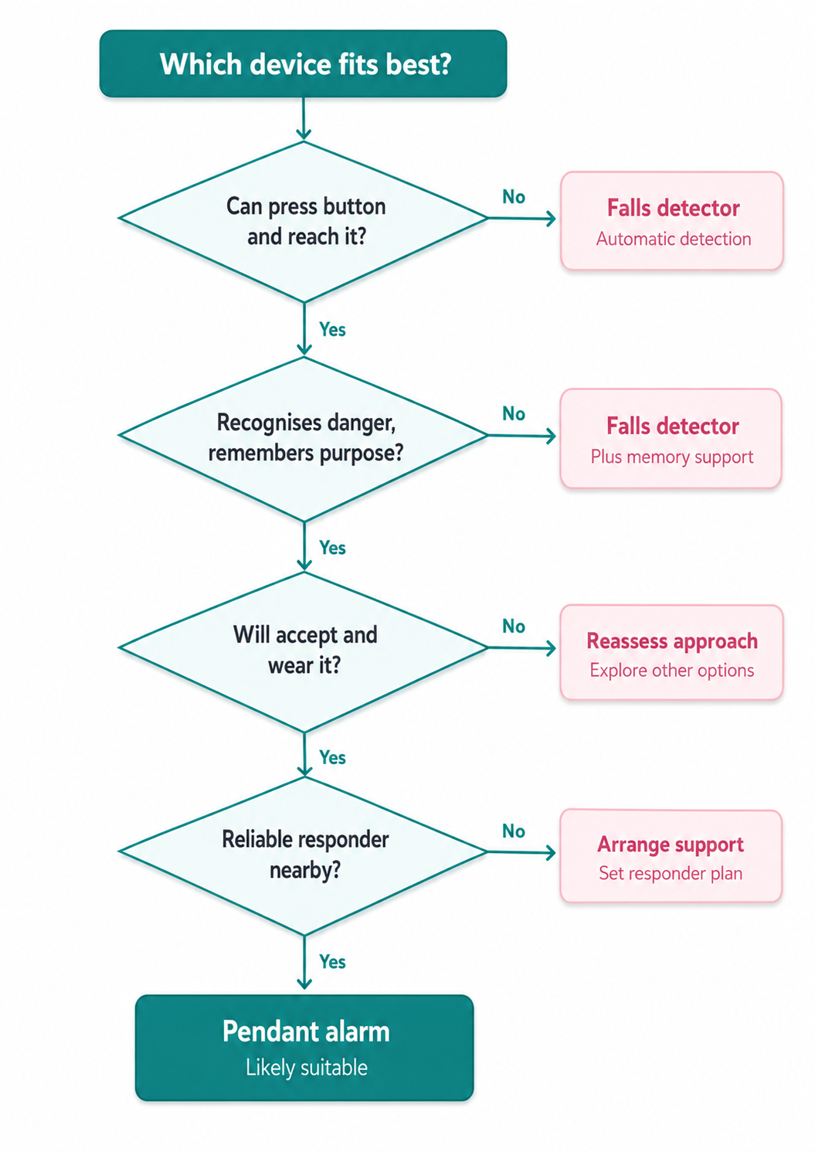

CONSIDERING MEMORY, COGNITION AND DEMENTIA
For someone with memory difficulties, choosing the right support is especially important. A person may:
- Forget to wear their alarm
- Forget how to use it
- Not recognise they are in danger
- Remove it because they do not understand its purpose
In these situations, families may need to consider additional supports such as:
- Regular check-ins from family or carers
- Medication support
- Home care visits
- Sensors or technology that provide extra reassurance
- Environmental changes to reduce risks

The question is not only:
“Can they use the equipment?”
It is also:
“Will this equipment realistically keep them safe in their everyday life?”

Final thought
The goal of equipment and telecare is not to make someone dependent. The goal is to help a person remain as independent as possible while reducing avoidable risks. A good discharge plan considers the person, their home, their abilities and the support around them. The right solution is different for everyone, and sometimes the smallest changes can have the biggest impact.
This leaflet is a general guide and does not replace individual clinical assessment. Please contact the ward Occupational Therapy team with any questions before discharge.

